**HOW TO CLEAN AND SHARPEN YOUR INCREMENT BORER**

**Keep your borer clean and sharp at all times!**

This will most likely prolong the lifetime of your borer and make it a better instrument. The borer tip can be cleaned with a small piece of soft paper tissue or cotton rag. Corrosion and dirt will eventually destroy the cutting edge. Any type of light oil can be used, sprayed directly into the borer bit and wiped with the tissue. Caution! The cutting edge is sharp and to avoid injury, wrap the tissue around for example the extractor tip, when cleaning. Steel wool can be used to remove rust.

**How to sharpen your borer bit with the COSHARP sharpening kit:**

The COSHARP kit contains of 1 bottle of light oil; 1 bottle of sharpening sand, beeswax and 3 different sharpening stones.

Pour a few drop of the light oil onto the flat stone.

Place the tip of the borer on the oil in a 40O angle and carefully move the tip back and forth while forth while rotating the bit. Put no pressure and do not use force. Continue until bit is sharp.

Apply a small amount of oil on the round stone (pointed end)

Insert the pointed end very carefully in the borer bit and rotate the borer shaft a few times only, until the inside of the borer is smooth. A magnifying glass can be helpful for better vision.

The sand is used to sharpen the tip of the borer if it is rusty, or has small chips. Drill a hole with a down angle, app. 2 cm depth in a tree or a piece of wood. Pour some of the sand into the hole and carefully drill in the borer again and sharpen the tip on the sand, half turn each direction. Some oil can be poured into the hole to reduce the friction. After having done this, clean the borer with a piece of paper or clean rag, and let the paper/rag pass through the entire borer bit from end to top to remove any excessive sand.

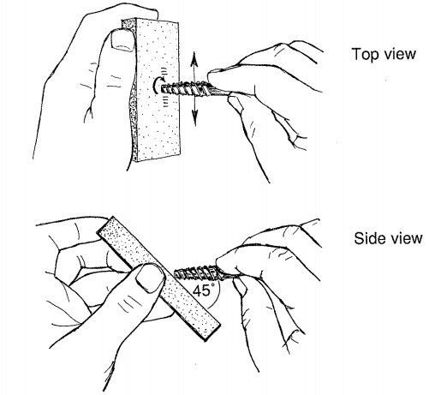 

Use the flat stone to sharpen the tip of the borer.

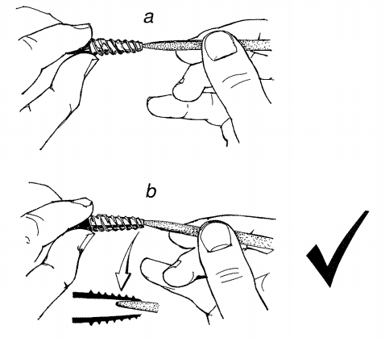 

Use the conical stone to smoothen the inside of the borer.

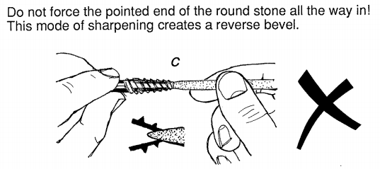

**Do not force the pointed end of the round stone all the way in!**

Pictures and facts courtesy of Les Jozsa, Research Scientist Wood Science Department, Forintek Canada Corp. March 1988 "Increment Core Sampling Techniques for High Quality Cores". Special Publication No. SP-30, ISSN#0824-2199, 1988.